Goal: This is an infographic resume for the website Upworthy. I’m applying for an online curator job. Essentially finding cool stuff on the internet and sharing it with other people. I want to be able to show that I have a strong history of producing viral videos and have improved each of the organizations I’ve been part of concerning social media.

Creative Guidance (just suggestions):
color scheme and texture:v
http://pinterest.com/pin/435301120202931693/

Use of Icons: I like how even though I can’t read the language the icons let me know what is going on.
http://pinterest.com/pin/171207223306381749/

Legend:
Color Coded:
Army: Dark Green
VA: Purple
EPA: Light Green
youtube.com/bumpthekoala: Blue

Sections:

SOCIAL MEDIA IMPACT:
(How many views I’ve created with three government agencies and my own Youtube channel):
I’d like it to read as a Youtube Analytic graph:
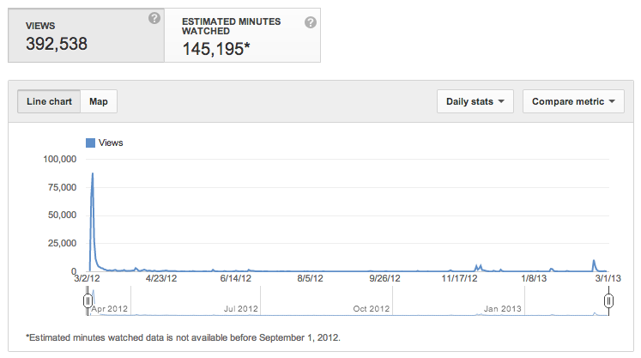

I like the way the timeline and legend are used here:
http://www.katbantad.com/blog/wp-content/uploads/2011/11/kbantad_infographic.tif

x is the year
y is the amount of hits
Short summary on total views (for known products) lining the bottom

Army (1997-2008): 50K+
Veterans Affairs (2008-2010): 450K+
EPA (2010-present): 100K+
youtube.com/users/bumpthekoala(2007-present): 2.5+ million
(not sure how to do this but the products were created during the dates in parenthesis but naturally social media wise the numbers have kept going up

NOTABLE ACHIEVEMENTS:
I like how easy to read the achievements are here: http://pinterest.com/pin/171207223306381982/

Army (1997-2008):
Bronze Star for service in Iraq (2004)
Department of the Army Broadcast Journalist of the Year (2007)
RNTDF Vada and Col. Barney Oldfield National Security Reporting Fellowship (2007)
Department of the Army’s first Regional Emmy (2008)

Veterans Affairs (2008-2010):
Executive Produced and marketed “Veterans Day 2010” http://youtu.be/RBfTQK5mPe8
and “Veterans Day 2011”
veach received 150K hits in a 24 hour period.
Department of Veterans Affairs first Regional Emmy (2009)

EPA (2010-present):
produced and marketed the first viral success for Agency
“Underneath the Surface: Address the Issues” received 72K through social media marketing (Upworthy) link: http://www.upworthy.com/this-is-just-my-opinion-but-thats-a-really-trashy-way-to-raise-a-child

youtube/user/bumpthekoala (2007-present):
Almost 2.5 million views
Over 180K minutes of watched content.
3 products with over 390K views
six products with over 100K views
Shit Civilians Say to Veterans (Upworthy)
Link: http://www.upworthy.com/all-the-things-you-should-probably-stop-saying-to-veterans

SKILLSETS:

Skillsets:
Social Media Marketer: Each agency I have worked for has reached thousands of new and existing stakeholder through social media marketing plans I helped conceive and execute.

Social Media Marketing: Helped my employers reach thousands of new and existing stakeholders through social media marketing plans I helped conceive and execute.

Viral Video Producer: I have made a career out of creating distinctive government videos that not only have high production values but communicate relatable information to audiences by the thousands.

Viral Video Producer: Focused on producing quality multimedia stories that an audience can react to, remember and share online

Project Management: Has managed thousands of high quality video projects with varying budgets over 13 years of production.

Project Management: Thrive in managing complex creative situations and transforming vague and complex issues into clear and effective projects.

CONTACT INFO:
I like how the contact info borders the top of the graph here.
Raymond Flores
bumpthekoala@gmail.com
703-969-9713
Linkedin: http://www.linkedin.com/pub/ray-flores/a/b14/86a

http://www.katbantad.com/blog/wp-content/uploads/2011/11/kbantad_infographic.tif

Top 10 videos

Ranger Rendezvous (Army): 833,389 views
http://youtu.be/McS5LmA6a4A

Soldier gets hit with a Stun Gun (Army): 436,408
http://youtu.be/O_XdoRbLhIo

S**t Civilians Say to Veterans (Personal): 393,376
http://www.upworthy.com/all-the-things-you-should-probably-stop-saying-to-veterans

Randy Couture- Army Soldier (Army): 236,154
http://youtu.be/dKw3YaWxzRI

Veterans Day 2010 (Veterans Affairs): 200,260
http://youtu.be/RBfTQK5mPe8

Veterans Day 2011 (Veterans Affairs): 176,276
http://youtu.be/xN2W429x_oA

Bunny Bath (Personal): 171,534
http://youtu.be/O-9BR2DF_Mg

Medal of Honor- PFC Ross McGinnis: SSG Ian Newland Interview: 82,043
http://youtu.be/dOClztsqAbY

Look Beneath the Surface- Address the Issues (EPA): 72,538
http://www.upworthy.com/this-is-just-my-opinion-but-thats-a-really-trashy-way-to-raise-a-child

Post 9/11 GI Bill Guide (Veterans Affairs): 43,735
http://youtu.be/6wwzie29m5Y

ScreenCap:
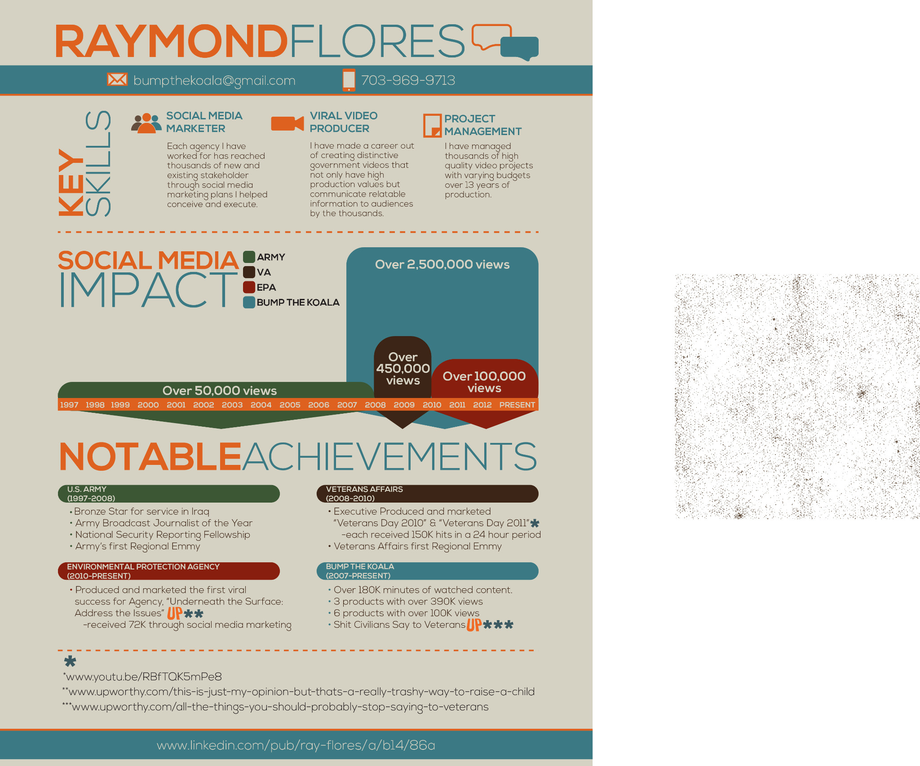

Revisions:
Over all I’m really happy.

1. I’d like the “legend” to read:
a. U.S. Army
b. Veterans Affairs
c. U.S. EPA
d. BUMPTHEKOALA (ALL ONE WORD)
2. In notable achievements I’d like it to read
a. Department of Veterans Affairs
b. youtube/users/bumpthekoala
3. In EPA section of notable achievements:
a. Remove the 72K hits bullet and replace with
“Received twice as many hits as any EPA existing product”

4. forget the quote

5. Can you make it S**t Civilians Say and put “ “ around them like the other stories.

6. My text revisions are up top in red and black.

Thanks again,
Ray

Quote:

mordecai.jpg

